File Ref: CCL 24 - LGOIMA 25.26.11

22 August 2025

Private individual
Via email

Dear private individual

Official information request regarding construction projects data
I refer to your official information request dated 16 July 2025 for information on construction projects that Council has been involved in. You requested data for all construction projects which are over $10 million in price and which have achieved practical completion in the last 5 years.
Westland District Council has not undertaken any projects in the last 5 years with a value over or in fact near $10 million.
There will be no charge for supplying this information to you.
Council has adopted a Proactive Release Policy and accordingly may publish LGOIMA responses on the Council Website at https://www.westlanddc.govt.nz/lgoima-responses. The collection and use of personal information by the Westland District Council is regulated by the Privacy Act 2020. Westland District Council's Privacy Statement is available on our website here
If you wish to discuss this decision with us, please feel free to contact Diane Maitland, Executive Assistant, on 027 503 9111.

Sincerely,
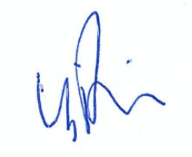

Barbara Phillips | Chief Executive

