File Ref: CCL 24 - LGOIMA 25.26.13

22 August 2025

Meg Fulford
Grey Star

Via email: meg.fulford@greystar.co.nz

Dear Meg
Official information request for actual rate rises for a sample of properties in the Westland District
I refer to your official information request dated 19 August 2025 for actual rate rises for a sample of properties in the Westland District.
You have requested the following information:
- Rates for a house in central Hokitika valued at $400,000
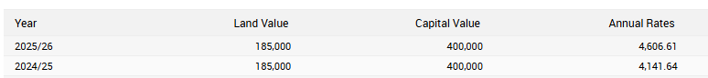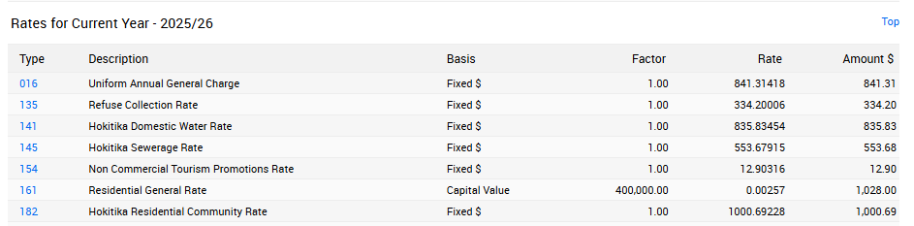
- Rates for a house in Ross valued at $400,000
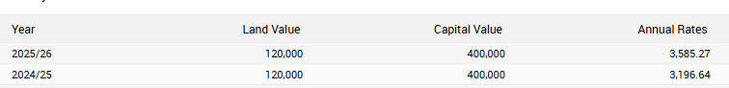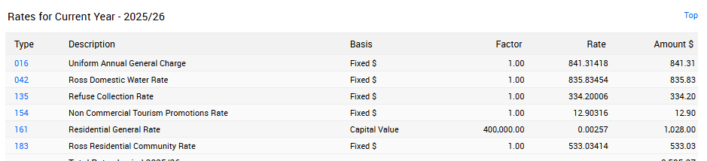

- Rates for a house in Hari Hari valued at $300,000
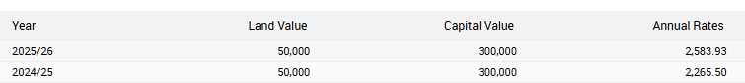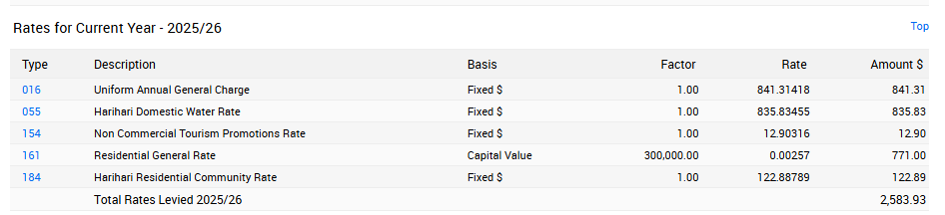
- Rates for a house outside of Hokitika valued at $800,000
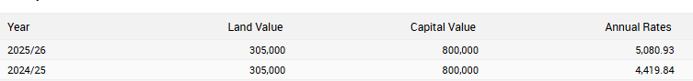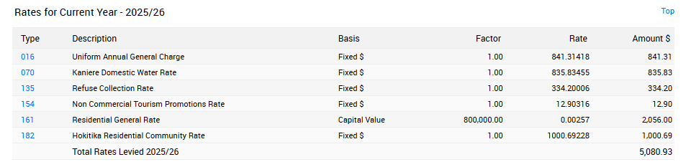
There will be no charge for supplying this information to you.
Council has adopted a Proactive Release Policy and accordingly may publish LGOIMA responses on the Council Website at https://www.westlanddc.govt.nz/lgoima-responses. The collection and use of personal information by the Westland District Council is regulated by the Privacy Act 2020. Westland District Council's Privacy Statement is available on our website here
If you wish to discuss this decision with us, please feel free to contact Diane Maitland, Executive Assistant, on 027 503 9111.

Sincerely,
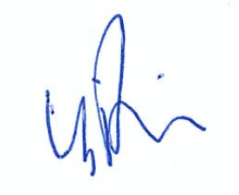

Barbara Phillips | Chief Executive

