File Ref: CCL 24 - LGOIMA 25.26.12

22 August 2025

Holly Bamber
Parliamentary Intern
Office of Teanau Tuiono, Green List MP
Wellington

Via email: Holly.Bamber@parliament.govt.nz

Official information request for information relating to road cones
I refer to your official information request dated 20 August 2025 for information relating to the number of road cones removed from roads controlled by Westland District Council
You have asked for the following information:
- The number of road cones which have been removed from roads controlled by Westland District Council as a result of tips submitted to the ‘Road Cone Digital Hotline’ since its launch on June 3rd 2025, and then forwarded to Westland District Council, as of August 15th 2025.
The answer to your query is nil.
- The number of other actions which have been taken as a result of tips submitted to the ‘Road Cone Digital Hotline’ and then forwarded to Westland District Council, as of August 15th 2025, broken down by type of action. Per Worksafe, 1 report has been forwarded to Westland District Council: Road cone reports data | WorkSafe
It appears that an email was submitted on 1 June 2025 and received by Westland District Council 10 days later. By that time, it is most likely that any roadworks being carried out in that location had long since finished and been taken down (due to the length of our District). The report appeared to be a malicious report and not even for our network.
There will be no charge for supplying this information to you.
Council has adopted a Proactive Release Policy and accordingly may publish LGOIMA responses on the Council Website at https://www.westlanddc.govt.nz/lgoima-responses. The collection and use of personal information by the Westland District Council is regulated by the Privacy Act 2020. Westland District Council's Privacy Statement is available on our website here
If you wish to discuss this decision with us, please feel free to contact Diane Maitland, Executive Assistant at WDCLGOIMA.Requests@westlanddc.govt.nz, 027 503 9111.

Sincerely,
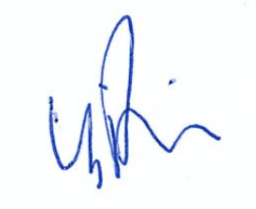
Barbara Phillips | Chief Executive

